39 Gordon Street, Huntly, Aberdeenshire AB54 8EQ

Telephone: 01466 792627 Fax: 01466 794962

VETERINARY SURGEONS
STRATHBOGIE VETERINARY CENTRE LTD

Its finishing time, cattle and sheep away to the slaughter house looking apparently healthy to the eye but then there is feedback from the abattoir detailing condemnations which have occurred. We often get questions asking what these mean – and abattoir feedback can be used in health planning and treating conditions that you may have not realised are there but have an impact on the productivity of an animal.
One of the main aims in beef and sheep farming is to produce a high quality meat end product. Rearing of these animals as you are fully aware, is not always plain sailing and many illnesses or diseases crop up along the way which not only can be deadly but also reduce the productivity of the animal. After all, we want the animal away fat as quickly as possible with maximal daily liveweight gains.

There are many common conditions discovered on post mortem examination at the abattoir. Post mortems can tell you a lot about what is going on on-farm and where changes can be made to prevent disease or allow better medical treatment of animals.

First up, abscesses. Many carcasses need to be trimmed of these abscesses. Abscesses are most commonly full of bacteria, commonly introduced by dirty needles! This transmits bacteria from animal to animal. Most commonly abscesses are found in the neck and rump regions of the animals – common sites for intramuscular injections. We would recommend injecting in the neck rather than the rump as this is a cheaper cut. Using sterile needles is best practice for injecting animals. But, is an abscess a minor matter? Well, if there are multiple abscesses in the carcase, the carcase can be totally condemned due to blood poisoning or systemic infection. Abscesses can also be found in the liver and lungs. These are often signs of long standing infection. Lung abscesses are quite commonly produced by bacteria which enter the lungs following on from viral infection. Clinically the animal is a poor doer and has bouts of respiratory disease/distress, nasal discharge and coughing. These abscesses are notoriously difficult to treat and get on top of. Long courses of Pen Strep can be good against these infections. Another common place for abscesses is the liver. These can be caused in a few ways; firstly tracking infection from navel ill as a calf (usually a poorer growing calf) and secondly following ruminal acidosis (animals fed a high concentrate diet).

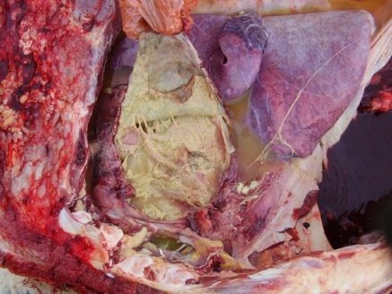The next condition is bit of a mouthful…. Traumatic reticulopericarditis aka hardware disease. I have diagnosed a few cases over the last year or two. This condition is most commonly caused when something sharp (most commonly ingested wire from tyres on the silage pit) are ingested. Over time the wire penetrates through the rumen wall, through the diaphragm and commonly through the pericardium (the sac surrounding the heart). Common findings on clinical examination are; temperature, lethargy, oedema (fluid accumulation at the lowest points (brisket and under the belly), sudden death. When listening to the heart we can hear ‘sloshing noises’. Long term treatment with Pen Strep can be beneficial but the outcome is commonly not great! Some animals don’t show signs until they really are at deaths door so may be picked up at the abattoir, otherwise they are picked up by us or the lab at post-mortem. Prevention is care on the silage pit or magnet boluses can be used so that the metal sticks to the magnet therefore less likely to penetrate through the rumen.

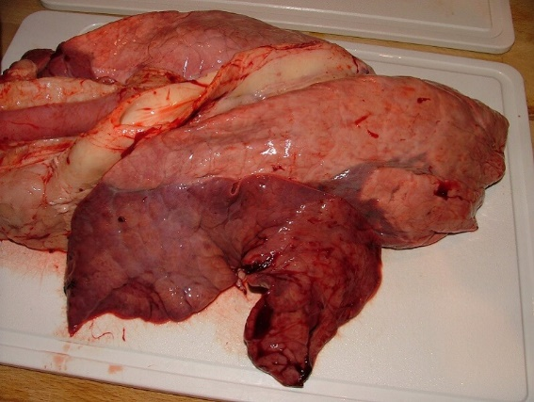The lungs are commonly commented on during post-mortem examination. Its amazing sometimes how bad lungs can look and unbelievable how the animal survived with the small amount of fully functioning lung that it had! There are a few classical signs to see on examinations which can give an indication of the causative agent of the pneumonia. First off, parasitic pneumonias – commonly seen at the bottom of the lungs and look like ‘elephant footprints!’ These can be inactive or active. Adult lungworm can also be seen in the windpipe and main parts of the lungs. Pneumonias are commonly initiated by four viral agents; RSV, PI3, IBR and BVD. Bacterial agents then take over when the virus causes damage to the lung tissue these mainly being your Pasteurellas (haemolytica and multocida), mycoplasma and histophilus somni. Pasteurellas are the most common causes of pneumonia in sheep. Typically there is some pleurisy present (reaction between the lung lining and the rib cage) and damage towards the top area of the lung. Mycoplasma is quite commonly seen in chronic lesions. Lab analysis could help determine the pathogens causing the pneumonias evident in the lung tissue, however as you are aware this is not done in the slaughterhouse. Feedback could help with further pneumonia investigations and finding the causal agent(s) and ultimately allowing a vaccination programme to be implemented on farm earlier on limiting the DLWG losses. With sheep Ovivac P Plus or Heptavac P Plus vaccinations cover for the Pasteurella component however on farms where incidence is high 6 monthly boosters may be required.

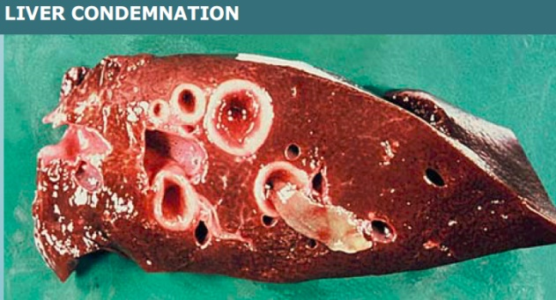Liver fluke is becoming more and more of an issue than previously due to it becoming more of a nationwide issue and resistance building to some drugs (triclabendazole mainly). Adult fluke live in the bile ducts of the liver. The bile ducts become thickened and calcified and are described as being ‘pipe stem like’ The liver over time becomes hypertrophied (larger) on the left and smaller on the right with chronic infection. On your reports if there are adult fluke present then treatment is recommended of animals left on farm. Severe acute fluke infection (especially in sheep) most commonly causes sudden death , so are not often seen post slaughter. If adult fluke are still being found in the livers despite dosing then resistance to drugs may be an issue too and this would need further investigation.

If you come across any of these and want to understand more then please contact us as on some occasions this can be significant.

Whilst on this subject…. all SUDDEN DEATHS MUST BE REPORTED TO US!! The ministry will pay for a visit by us to take samples to ensure that the cause of the death isn’t anthrax. Movement restrictions on the animal is put on place whilst we look at the sample for any signs.

Post Mortems can be a useful way of disease surveillance on farm and we are always happy to PM things to try and establish a cause of death. The SAC also offers subsidised post-mortems which are good value for money.

Pictures from;
http://www.engormix.com/MA-ganaderia-carne/fotos/pericarditis-traumatica-novillo-ph5035/p0.htm

https://www.virbac.co.za/home/farmer/products/internal-paracitisides--download/liver-fluke-in-cattle--the-econo.html

https://www.vetstream.com/treat/bovis/illustration/pneumonia-post-mortem

